New Year’s Eve
December 31st, 2019
St. Peter's Lutheran Church
Pastor Timothy Roth
Pastor Donald Copley
office@stpetershumboldt.org
pastor@stpetershumboldt.org
www.stpetershumboldt.org

Hymn of Invocation 899 Across the Sky the Shades of Night
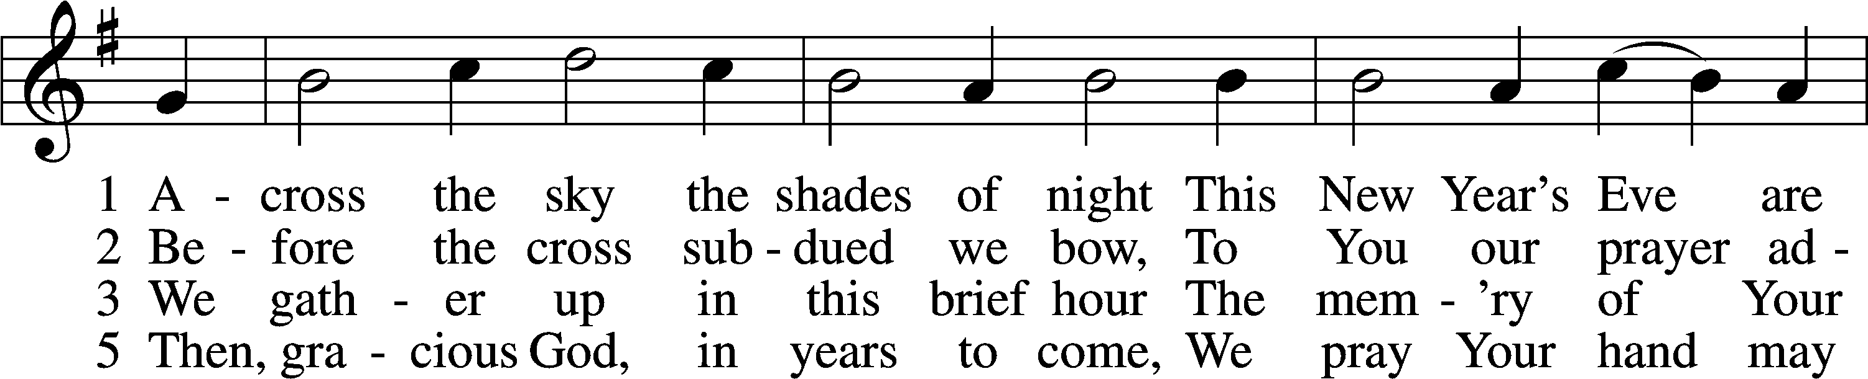
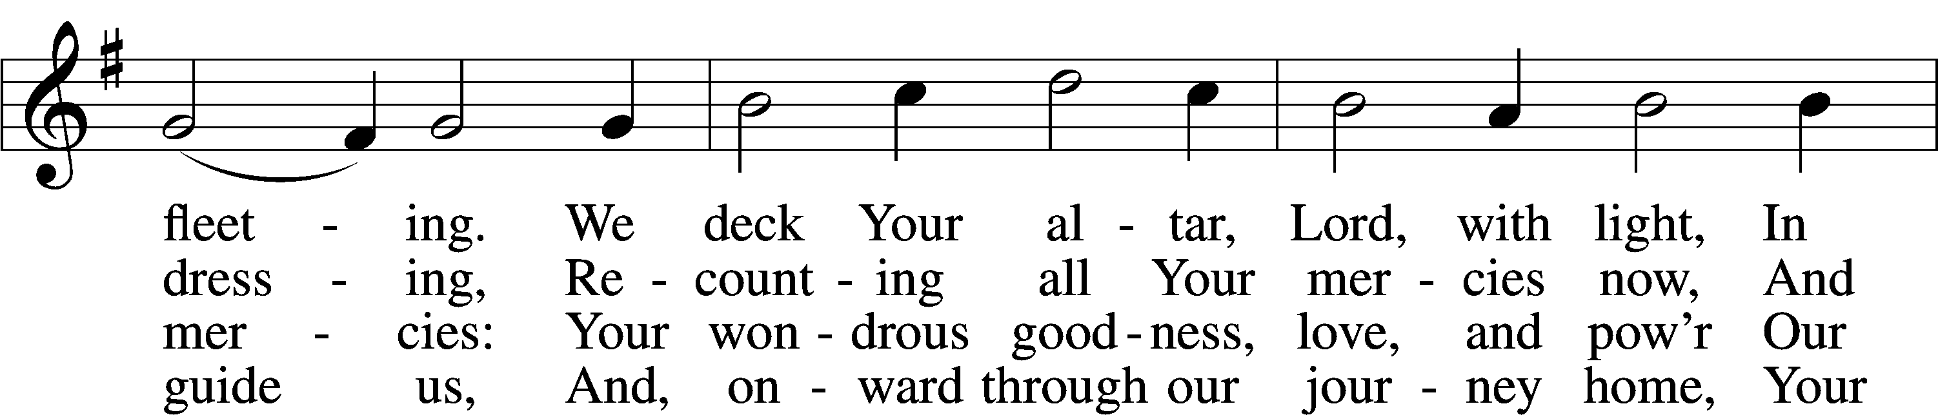
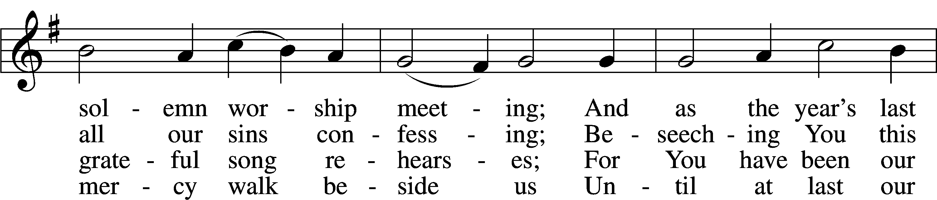
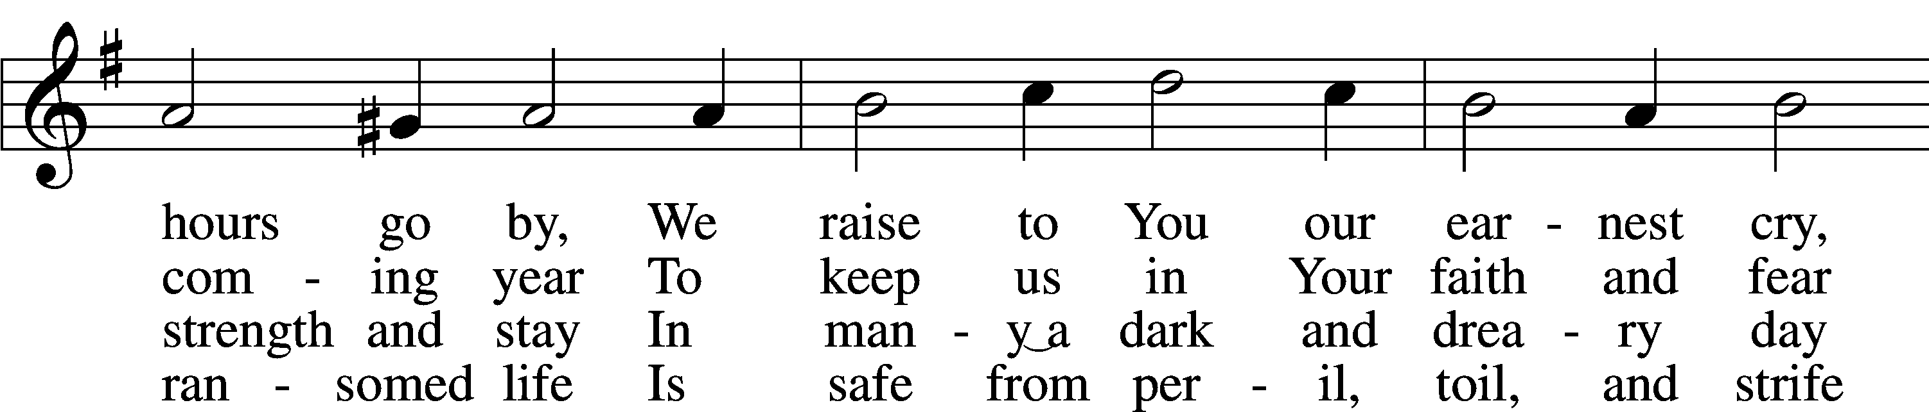
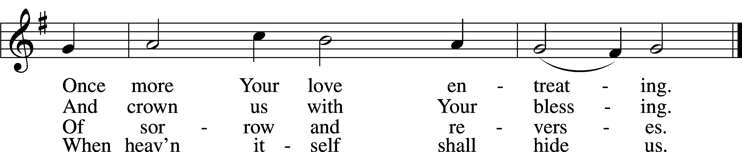
Invocation, Opening Sentences, Confession and Absolution
P In the name of the Father and of the T Son and of the Holy Spirit. C Amen.
P Our help is in the name of the Lord, C who made heaven and earth.
Psalm 124:8
P Of old you laid the foundation of the earth,
C and the heavens are the work of your hands.
P They will perish, but you will remain; C they will all wear out like a garment.
Psalm 102:25-26a
P All flesh is grass, C and all its beauty is like the flower of the field.
P The grass withers, the flower fades,
C but the word of our God will stand forever.
Isaiah 40:6b-8
P The steadfast love of the Lord never ceases;
C his mercies never come to an end;
P they are new every morning; C great is your faithfulness.
P The Lord is my portion,” says my soul, C “therefore I will hope in him.”
P The Lord is good to those who wait for him, C to the soul who seeks him.
P It is good that one should wait quietly C for the salvation of the Lord.
Lammentations 3:22-26
P For I the Lord do not change;
C therefore you, O children of Jacob, are not consumed.
P From the days of your fathers you have turned aside from my statutes and have not kept them.
C Return to me, and I will return to you, says the Lord of hosts.
Malachi 3:6-7b
P Remember not the former things, C nor consider the things of old.
P Behold, I am doing a new thing;
C now it springs forth, do you not perceive it?
P I will make a way in the wilderness C and rivers in the desert.
Isaiah 43:18-19
P The Lord is merciful and gracious,
C slow to anger and abounding in steadfast love.
P He will not always chide, C nor will he keep his anger forever.
P He does not deal with us according to our sins,
C nor repay us according to our iniquities.
P For as high as the heavens are above the earth,
C so great is his steadfast love toward those who fear him;
P as far as the east is from the west,
C so far does he remove our transgressions from us.
P As a father shows compassion to his children,
C so the Lord shows compassion to those who fear him.
P For he knows our frame; C he remembers that we are dust.
P As for man, his days are like grass; C he flourishes like a flower of the field;
P for the wind passes over it, and it is gone, C and its place knows it no more.
P But the steadfast love of the Lord is from everlasting to everlasting on those who fear him,
P and his righteousness to children's children,
P to those who keep his covenant C and remember to do his commandments.
P The Lord has established his throne in the heavens,
C and his kingdom rules over all.
Psalm 103:8-19
P Send out your light and your truth; C let them lead me;
P let them bring me to your holy hill C and to your dwelling!
P Then I will go to the altar of God,
C to God my exceeding joy, and I will praise you.
Psalm 43:3-4
P Jesus Christ is the same yesterday and today and forever.
C Through him then let us continually offer up a sacrifice of praise to God, that is, the fruit of lips that acknowledge his name.
Hebrews 13:8, 15
P Beloved in the Lord, the old is gone and the new has come. As we face an ending and a new beginning, let us also consider our old sinful selves to be put away and the new self, who walks in the light and the love of Christ by the power of His Spirit, shine forth brightly into the night.
Let us go the altar of the Lord, letting His light and truth lead us to examine ourselves and confess our sin unto Him, that as far as the east is from the west, so our sins will be removed from us in Christ Jesus, our Lord.
We examine ourselves according to our various callings and place in life that God has given to us according to His Ten Commandments, pausing for a moment of silent self-reflection after each one. On this New Year’s Eve night, let God’s mercy make a way in the wilderness of our sin and His grace flow like a river in the desert of our corruption:
The First Commandment—You shall have no other gods.
C We should fear, love, and trust in God above all things.
P All people are constantly looking for happiness, identity, security, and meaning in life. Where have you placed your trust this past year? Where have you turned in your time of need? Where have you looked for your well-being and all your good? Have you defined for yourself what God alone can define, or sought His glory for yourself? Have you denied the true God through your words or actions? We pause to reflect on this commandment and repent of our sins.
P The Second Commandment—You shall not misuse the name of the Lord your God.
C We should fear and love God so that we do not curse, swear, use satanic arts, lie, or deceive by His name, but call upon it in every trouble, pray, praise, and give thanks.
P When we trust God with our hearts, we use our lips to call upon Him as our Creator and Redeemer. How have you used God’s name this past year? How have you spoken of Him? Have you used His name thoughtlessly or carelessly? Have you called upon Him to do your own will? Have you used His name to deceive others? Have you represented His name accurately? ave you sought God by another name? Have you called upon Him as children call upon their father, seeking all good things for yourself and for others? Have you called upon Him in times of trouble? Have you acknowledged Him in thanks and praise for the good that you have? Have you spoken truthfully about Him, and shared His name with all people, especially those who do not know Him? We pause to reflect and repent.
P The Third Commandment—Remember the Sabbath day by keeping it holy.
C We should fear and love God so that we do not despise preaching and His Word, but hold it sacred and gladly hear and learn it.
P God invites us to rest, reflect on His Word, and receive His forgiveness in order to strengthen our faith in Him. Do you spend your time in a way that honors Him? Have you set aside time to rest and reflect on His Word and promises? Have you sought Him where He promises to be found, in His Word and Sacrament? Have you devoted yourself to studying His Word diligently? Have you treasured His Word in your heart and held it sacred? Have you rejected or disreguared any part of God’s Word? Have you despised the preaching of His Word? Have you neglected to gather together for public worship? We pause to reflect and repent.
P The Fourth Commandment—Honor your father and your mother.
C We should fear and love God so that we do not despise or anger our parents and other authorities, but honor them, serve and obey them, love and cherish them.
P God has given parents a unique task that serves the well-being of all society. God has also given other authorities to serve as His representatives for our support and protection. Have you honored and cherished your parents as gifts of God and His representatives on earth? Have you served your parents and come to their aid? Have you obeyed your parents and other authorities God has placed over you? Have you despised, looked down upon, disobeyed, or rebelled againt those God has placed over you? If you have been in the place of authority, have you fulfilled your task in an honorable way? Have you exasterbated or abused those under your authority? Have you faithfully represented God to those in your care? We pause to reflect and repent.
P The Fifth Commandment—You shall not murder.
C We should fear and love God so that we do not hurt or harm our neighbor in his body, but help and support him in every physical need.
P God created us to care about other people and to help them in their times of need. Have you treated all people with kindness and compassion? Have you acted or spoken to protect someone else from bodily harm? Have you hurt or harmed anyone by your words or deeds? Have you done or said anything that injured or endangered someone’s life? Have you neglected to serve someone or left them in need when you could have helped? Have you harbored anger or hatred against someone or wished them ill? Have you engaged in any self-destructive or self-harming behaviors? We pause to reflect and repent.
P The Sixth Commandment—You shall not commit adultery.
C We should fear and love God so that we lead a sexually pure and decent life in what we say and do, and husband and wife love and honor each other.
P God created us to live faithfully as male and female by respecting His purpose for sexual activity within the context of marriage, which He has instituted as a lifelong union between one man and one woman for mutual help and joy and for the procreation and nurturing of children. Have you treated God’s gift of marriage lightly or despised His institution of it? Have you removed His gift of sexual intercourse from His institution of marriage? Have you treated the bodies of others or your own body as holy and temples of the Holy Spirit? Have you clothed your bodies with modesty? Have you by thought, word, or deed taken someone’s dignity and modesty by treating them as an objects to serve your selfish desires? Have you spoken or acted toward someone in a way that demans them in their body? Have you spoken or acted to defend someone who is being demaned or taken advantage of sexually? Have you refrained from all forms of lustful desires or activity? Have you treasured your spouce or failed to be faithful in all you say and do, or if you do not have a spouce have you remained undefiled and lived in contentment? We pause to reflect and repent.
P The Seventh Commandment—You shall not steal.
C We should fear and love God so that we do not take our neighbor’s money or possessions, or get them in any dishonest way, but help him to improve and protect his possessions and income.
P God created us to look after the earthly gifts that He has given to our neighbors for their life and well-being. Have you taken anything, on prupose or on accident, that belongs to your neighbor? Have you tricked someone out of something that belonged to them? Have you taken advantage of anyone with their possessions? Have you damaged anything, or allowed anything to be damaged, that belongs to someone else? Have you been a faithful employee? Have you done what you could do protect and care for the property of others? We pause to reflect and repent.
P The Eighth Commandment—You shall not give false testimony against your neighbor.
C We should fear and love God so that we do not tell lies about our neighbor, betray him, slander him, or hurt his reputation, but defend him, speak well of him, and explain everything in the kindest way.
P God commands us to speak truthfully and charitably about our neighbors so that others view them in the best possible light. Have you spoken lies or spread rumors about anyone? Have you harmed anyone’s reputation with your words or actions? Have you revealed publicly anyone’s private faults or secrets? Have you sought to understand others in the most positive light? Have you put the best construction on other’s actions? Have you defended people when they weren’t there to speak for themselves? Have you drawn attention to the good qualitites in people? We pause to reflect and repent.
P The Ninth Commandment—You shall not covet your neighbor’s house.
C We should fear and love God so that we do not scheme to get our neighbor’s inheritance or house, or get it in a way which only appears right, but help and be of service to him in keeping it.
P The Tenth Commandment—You shall not covet your neighbor’s wife, or his manservant or maidservant, his ox or donkey, or anything that belongs to your neighbor.
C We should fear and love God so that we do not entice or force away our neighbor’s wife, workers, or animals, or turn them against him, but urge them to stay and do their duty.
P God created us to be content with the gifts by which He sustains our life. Have you been content with the things that God has given to you? Do you give thanks to God for what He has given? Do you care for the things that God has given to you? Have you tried to figure out how to get what belongs to your neighbor? Have you tried to lure away your neighbor’s spouce, children, friends or employwees, or turn them against your neighbor? Have you encouraged your neighbors spouce, children, friends, and employees to stay faithful and loyal to your neighbor? We pause to reflect and repent.
P When we examine ourselves according to God’s Commandments we find that we are truly sinful and in need of God’s mercy:
C O almighty God, merciful Father, I, a poor, miserable sinner, confess unto You all my sins and iniquities with which I have ever offended You and justly deserved Your temporal and eternal punishment. But I am heartily sorry for them and sincerely repent of them, and I pray You of Your boundless mercy and for the sake of the holy, innocent, bitter sufferings and death of Your beloved Son, Jesus Christ, to be gracious and merciful to me, a poor, sinful being.
P God be merciful to you and strengthen your faith. C Amen.
P Do you believe that the forgiveness I speak is not my forgiveness but God’s?
C Yes.
P Let it be done for you as you believe.
At this time, all are invited up front who wish to receive private absolution. For those do not desire or are unable to come up front, pastor will conclude by addressing the whole congregation.
In the stead and by the command of my Lord Jesus Christ I forgive you all your sins in the name of the Father and of the T Son and of the Holy Spirit. C Amen.
P Now may the God of peace Himself sanctify you completely, and may your whole spirit, soul, and body be kept blameless at the coming of our Lord Jesus Christ. He who calls you is faithful; He will surely do it. Go in T peace. C Amen.
Kyrie, Salutation & Collect of the Day
P Lord, C have mercy. Christ, have mercy. Lord, have mercy. Amen.
P The Lord be with you. C And also with you.
P Eternal God, we commit to Your mercy and forgiveness the year now ending and commend to Your blessing and love the times yet to come. In the new year, abide among us with Your Holy Spirit that we may always trust in the saving name of our Lord Jesus Christ,who lives and reigns with You and the Holy Spirit, one God, now and forever. C Amen.
Introit
P Our help is in the name of the Lord, who made heaven and earth.
C Oh sing to the Lord a new song, for he has done marvelous things!
His right hand and his holy arm have worked salvation for him.
P The Lord has made known his salvation;
he has revealed his righteousness in the sight of the nations.
C He has remembered his steadfast love and faithfulness to the house of Israel. All the ends of the earth have seen the salvation of our God.
Old Testament Reading Isaiah 30:15–17
For thus said the Lord God, the Holy One of Israel, “In returning and rest you shall be saved; in quietness and in trust shall be your strength.” But you were unwilling, and you said, “No! We will flee upon horses”; therefore you shall flee away; and, “We will ride upon swift steeds”; therefore your pursuers shall be swift. A thousand shall flee at the threat of one; at the threat of five you shall flee, till you are left like a flagstaff on the top of a mountain, like a signal on a hill.
P This is the Word of the Lord. C Thanks be to God.
Gradual & Psalm 90:1–12
P Teach us to number our days that we may get a heart of wisdom.
C Satisfy us in the morning with Your steadfast love,
that we may rejoice and be glad all our days.
P Lord, you have been our dwelling place in all generations.
C Before the mountains were brought forth,
or ever you had formed the earth and the world,
from everlasting to everlasting you are God.
P You return man to dust and say, “Return, O children of man!”
C For a thousand years in your sight
are but as yesterday when it is past, or as a watch in the night.
P You sweep them away as with a flood;
they are like a dream, like grass that is renewed in the morning:
C in the morning it flourishes and is renewed;
in the evening it fades and withers.
P For we are brought to an end by your anger; by your wrath we are dismayed.
C You have set our iniquities before you,
our secret sins in the light of your presence.
P For all our days pass away under your wrath;
we bring our years to an end like a sigh.
C The years of our life are seventy, or even by reason of strength eighty;
P yet their span is but toil and trouble; they are soon gone, and we fly away.
C Who considers the power of your anger,
and your wrath according to the fear of you?
P So teach us to number our days that we may get a heart of wisdom
Epistle Romans 8:31b–39
If God is for us, who can be against us? He who did not spare his own Son but gave him up for us all, how will he not also with him graciously give us all things? Who shall bring any charge against God’s elect? It is God who justifies. Who is to condemn? Christ Jesus is the one who died—more than that, who was raised—who is at the right hand of God, who indeed is interceding for us. Who shall separate us from the love of Christ? Shall tribulation, or distress, or persecution, or famine, or nakedness, or danger, or sword? As it is written,
“For your sake we are being killed all the day long;
we are regarded as sheep to be slaughtered.”
No, in all these things we are more than conquerors through him who loved us. For I am sure that neither death nor life, nor angels nor rulers, nor things present nor things to come, nor powers, nor height nor depth, nor anything else in all creation, will be able to separate us from the love of God in Christ Jesus our Lord.
P This is the Word of the Lord. C Thanks be to God.
Holy Gospel Reading Luke 12:35-40
P Alleluia. The steadfast love of the Lord is from everlasting to everlasting,
C to those who fear Him. Alleluia.
P The Holy Gospel according to St. Matthew, the twenty-fourth chapter.
C Glory to You, O Lord.
[Jesus said:] “Stay dressed for action and keep your lamps burning, and be like men who are waiting for their master to come home from the wedding feast, so that they may open the door to him at once when he comes and knocks. Blessed are those servants whom the master finds awake when he comes. Truly, I say to you, he will dress himself for service and have them recline at table, and he will come and serve them. If he comes in the second watch, or in the third, and finds them awake, blessed are those servants! But know this, that if the master of the house had known at what hour the thief was coming, he would not have left his house to be broken into. You also must be ready, for the Son of Man is coming at an hour you do not expect.”
P This is the Gospel of the Lord. C Praise to You, O Christ.
Hymn of the Day 733 O God Our Help in Ages Past
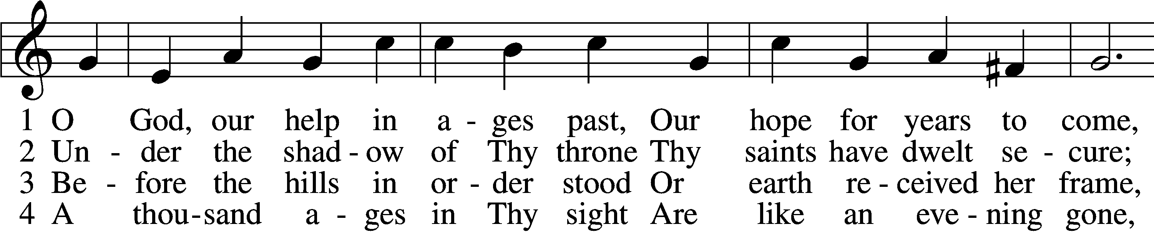
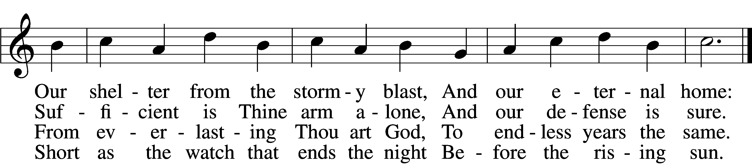

5 Time, like an ever-rolling stream,
Soon bears us all away;
We fly forgotten as a dream
Dies at the op’ning day.
6 O God, our help in ages past,
Our hope for years to come,
Be Thou our guard while troubles last
And our eternal home!

Apostles’ Creed
Meditation
The Litany
P O Lord, C have mercy. P O Christ, C have mercy.
P O Lord, C have mercy. P O Christ, C hear us.
P God the Father in heaven, C have mercy.
P God the Son, Redeemer of the world, C have mercy.
P God the Holy Spirit, C have mercy.
P Be gracious to us. C Spare us, good Lord.
P Be gracious to us. C Help us, good Lord.
P From all sin, from all error, from all evil; From the crafts and assaults of the devil; from sudden and evil death; From pestilence and famine; from war and bloodshed; from sedition and from rebellion; From lightning and tempest; from all calamity by fire and water; and from everlasting death: C Good Lord, deliver us.
P By the mystery of Your holy incarnation; by Your holy nativity; By Your baptism, fasting, and temptation; by Your agony and bloody sweat; by Your cross and passion; by Your precious death and burial; By Your glorious resurrection and ascension; and by the coming of the Holy Spirit, the Comforter: C Help us, good Lord.
P In all time of our tribulation; in all time of our prosperity; in the hour of death; and in the day of judgment: C Help us, good Lord.
P We poor sinners implore You C to hear us, O Lord.
P To rule and govern Your holy Christian Church; to preserve all pastors and ministers of Your Church in the true knowledge and understanding of Your wholesome Word and to sustain them in holy living; To put an end to all schisms and causes of offense; to bring into the way of truth all who have erred and are deceived; To beat down Satan under our feet; to send faithful laborers into Your harvest; and to accompany Your Word with Your grace and Spirit: C We implore You to hear us, good Lord.
P To raise those who fall and to strengthen those who stand; and to comfort and help the weakhearted and the distressed: C We implore You to hear us, good Lord.
P To give to all peoples concord and peace; to preserve our land from discord and strife; to give our country Your protection in every time of need; To direct and defend our president and all in authority; to bless and protect our magistrates and all our people; To watch over and help all who are in danger, necessity, and tribulation; to protect and guide all who travel; To grant all women with child, and all mothers with infant children, increasing happiness in their blessings; to defend all orphans and widows and provide for them; To strengthen and keep all sick persons and young children; to free those in bondage; and to have mercy on us all:
C We implore You to hear us, good Lord.
P To forgive our enemies, persecutors, and slanderers and to turn their hearts; to give and preserve for our use the kindly fruits of the earth; and graciously to hear our prayers: C We implore You to hear us, good Lord.
P Lord Jesus Christ, Son of God, C we implore You to hear us.
P Christ, the Lamb of God, who takes away the sin of the world, C have mercy.
P Christ, the Lamb of God, who takes away the sin of the world, C have mercy.
P Christ, the Lamb of God, who takes away the sin of the world,
C grant us Your peace.
P O Christ, C hear us. P O Lord, C have mercy.
P O Christ, C have mercy. P O Lord, C have mercy. Amen.
T Service of the Sacrament T

Preface & Sanctus 2 Tim. 4:22; Col. 3:1; Ps. 136; Isaiah 6:3; Mat. 21:9
P The Lord be with you. C And also with you.
P Lift up your hearts. C We lift them to the Lord.
P Let us give thanks to the Lord our God.
C It is right to give Him thanks and praise.
P It is truly good, right, and salutary that we should at all times and in all places give thanks to You, holy Lord, almighty Father, everlasting God, through Jesus Christ, our Lord; for in the mystery of the Word made flesh You have given us a new revelation of Your glory that, seeing You in the person of Your Son, we may know and love those things which are not seen. Therefore with angels and archangels and with all the company of heaven we laud and magnify Your glorious name, evermore praising You and saying:
C Holy, holy, holy Lord, Lord God of pow’r and might: Heav’n and earth are full of Your glory. Hosanna in the highest. Blessed is He who comes in the name of the Lord. Hosanna in the highest.
Lord’s Prayer, The Words of Our Lord & Pax Domini John 20:19
P The peace of the Lord be with you always. C Amen.
Post-Communion Collect
P We give thanks to You, almighty God, that You have refreshed us through this salutary gift, and we implore You that of Your mercy You would strengthen us through the same in faith toward You and in fervent love toward one another; through Jesus Christ, Your Son, our Lord, who lives and reigns with You and the Holy Spirit, one God, now and forever. C Amen.
Benedicamus & Benediction Psalm 103:1; Numbers 6:24-26
P Let us bless the Lord. C Thanks be to God.
P The Lord bless you and keep you.
The Lord make His face shine on you and be gracious to you.
The Lord look upon you with favor and T give you peace.
C Amen
Hymn to Depart 922 Go, My Children, with My Blessing

